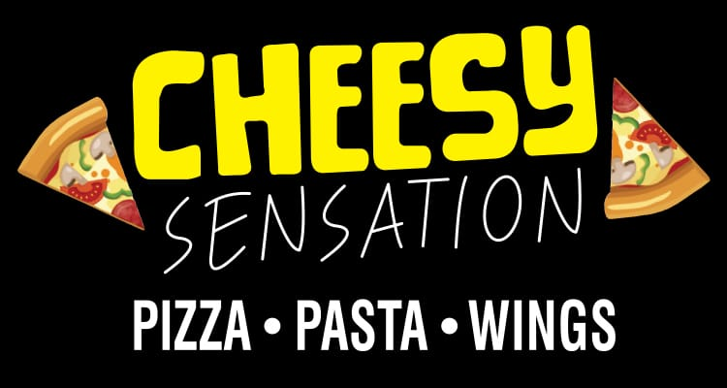
Thank you for visiting Cheesy Sensation!
Stay updated with our latest deals and offers by joining our text messaging service.
Simply text “CHEESY” to (844) 712-2837.

